Practical No.04

Q.1] Develop app in AngularJS to display “Good Morning” message in Browser.

<!DOCTYPE HTML>
<html ng-app="Myapp">
<head>
<title>AngularJS Show Example</title>
<script src="https://ajax.googleapis.com/ajax/libs/angularjs/1.8.2/angular.min.js"></script>
</head>

<body ng-controller="MyCtrl">
<p>{{ message }}</p>
<script>
var app = angular.module("Myapp", []);
app.controller("MyCtrl", function ($scope) {
$scope.message = "Good Morning";
});
</script>
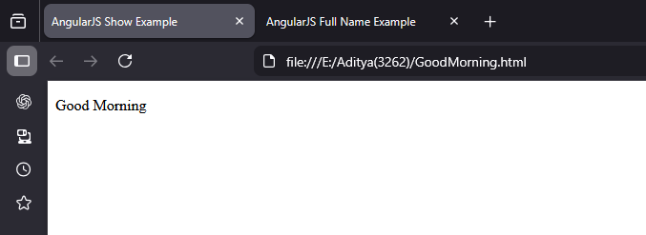
</body>
</html>

Output :-

Q.2] Create Angular App to display “Hello World” message.

<!DOCTYPE html>
<html ng-app="HelloApp">
<head>
<title>AngularJS Hello World</title>
<script src="https://ajax.googleapis.com/ajax/libs/angularjs/1.8.2/angular.min.js"></script>
</head>

<body ng-controller="HelloCtrl">

<h2>{{ message }}</h2>
<script>
var app = angular.module("HelloApp", []);
app.controller("HelloCtrl", function ($scope) {
$scope.message = "Hello World";
});
</script>

</body>
</html>

Output:-
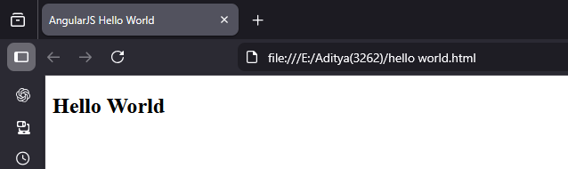

Q. Installation of the node js (install angular software application)

